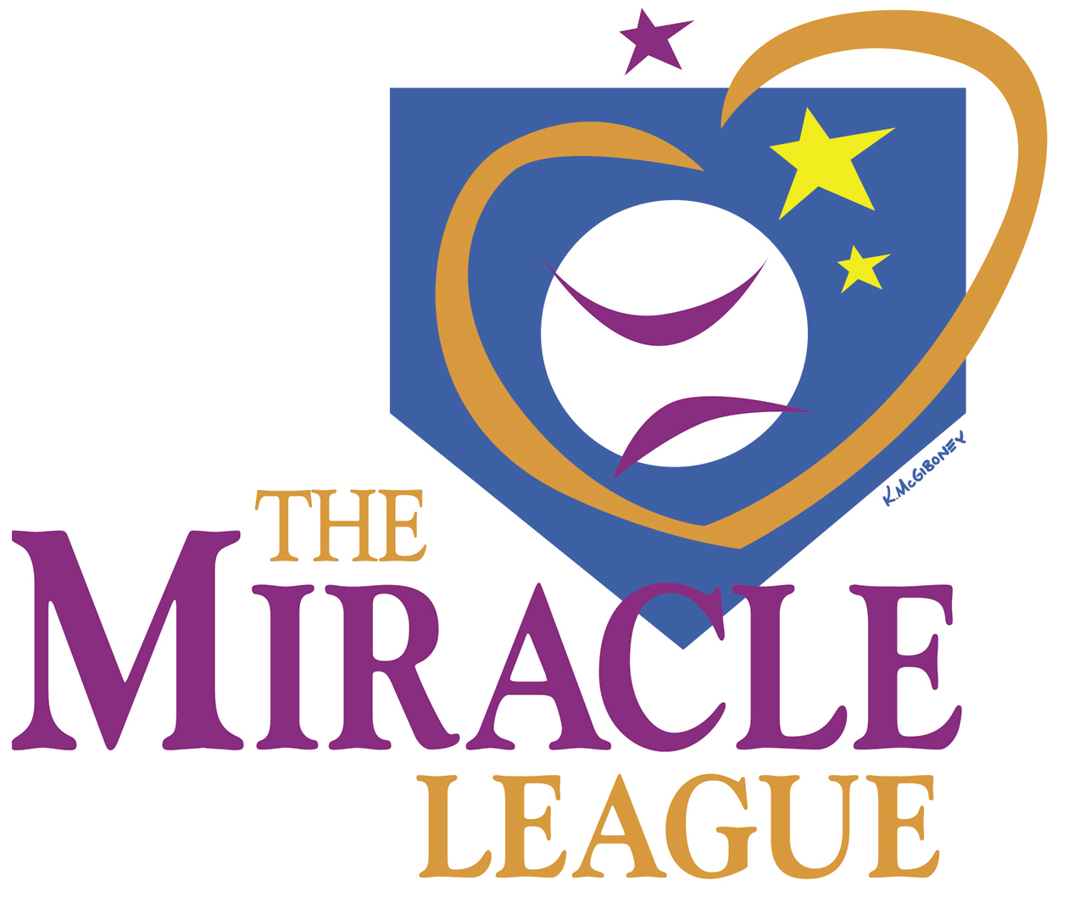 www.miracleleagueofmacon.org

Sponsorship Commitment Form – 2024

Sponsor / Company Name: _________________________________________

Contact Person’s Name: ___________________________________________

Address: ________________________________________________________

City: _______________________ State: __________ Zip: ________________

Phone: _____________________ Fax: ______________________________

Email: _______________________________________________

If there is a specific Miracle League team or a specific player’s team you want to sponsor, please list the team or player’s name below, and we will and try and honor your request.
Team or Player’s Name: _________________________________

Select Sponsorship Level (Check one):

______ GRAND SLAM ($1000)

______ HOME RUN ($500)

______ TRIPLE ($250)

Please make checks payable to: MIRACLE LEAGUE OF MACON

Mail to: Miracle League of Macon
PO Box 26816
Macon, GA 31221

Sponsor Signature: _____________________________________

